This post was published to Code Blog at 3:33:00 PM 3/24/2017

Donut Chart With OxyPlot

Category .NET ; C# ; Xamarin

[Top Level For Projects (Market Sell)](https://dow-vsts.visualstudio.com/Market%20Sell/_versionControl?path=$/Market%20Sell/CodeShare/Team%20Projects&version=T&_a=contents)

Then go to Codeshare/Team Projects/OxyPlot

The oxy:PlotView resource has a converter class that was written by another developer to handle the changing values of whatever value you want to assign to (Percentage filled in my case).  Value1 is the percentage, but the binding was set through the IValueConverter used by Microsoft to allow XAML to connect to the code behind.  Replacing with PurpleDonutConverter in the static resource definition would change the color to purple.  The next clip will show how that happens.

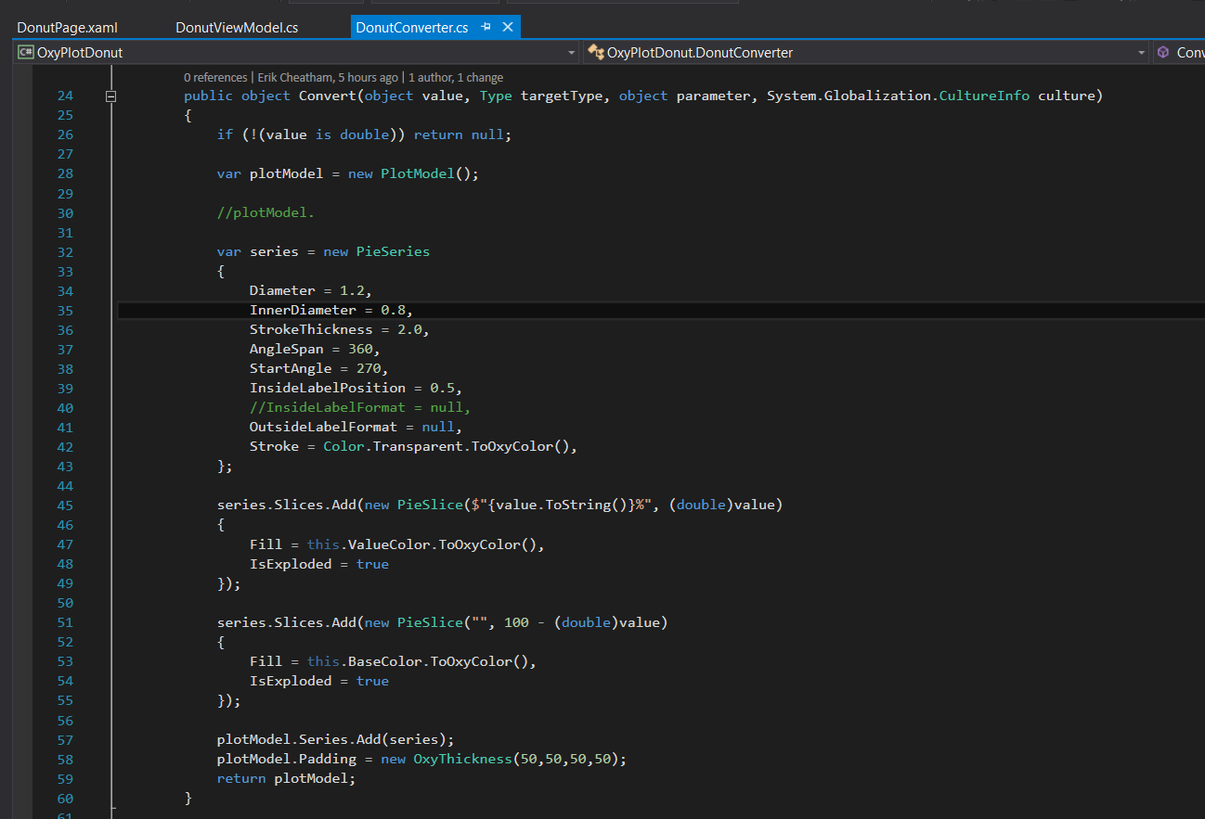

Now the diameters actually define the thickness for the line in the chart, and the inside label position is where in the line the value text will appear, so you can see that I set the value to be shown as a percentage and I suppose you could put some formatting on the text, but I didn't go that far, it would probably be in defining the inside label format, instead I commented that out and only defined the inside label position, lastly the oxy thickness at the bottom defines the padding from the outsides of the rendered control to where the line for the graph starts (This is important because Android version 6.0 Nougat actually cuts down on the control for some reason and will cut some of each of the lines into a box formation.

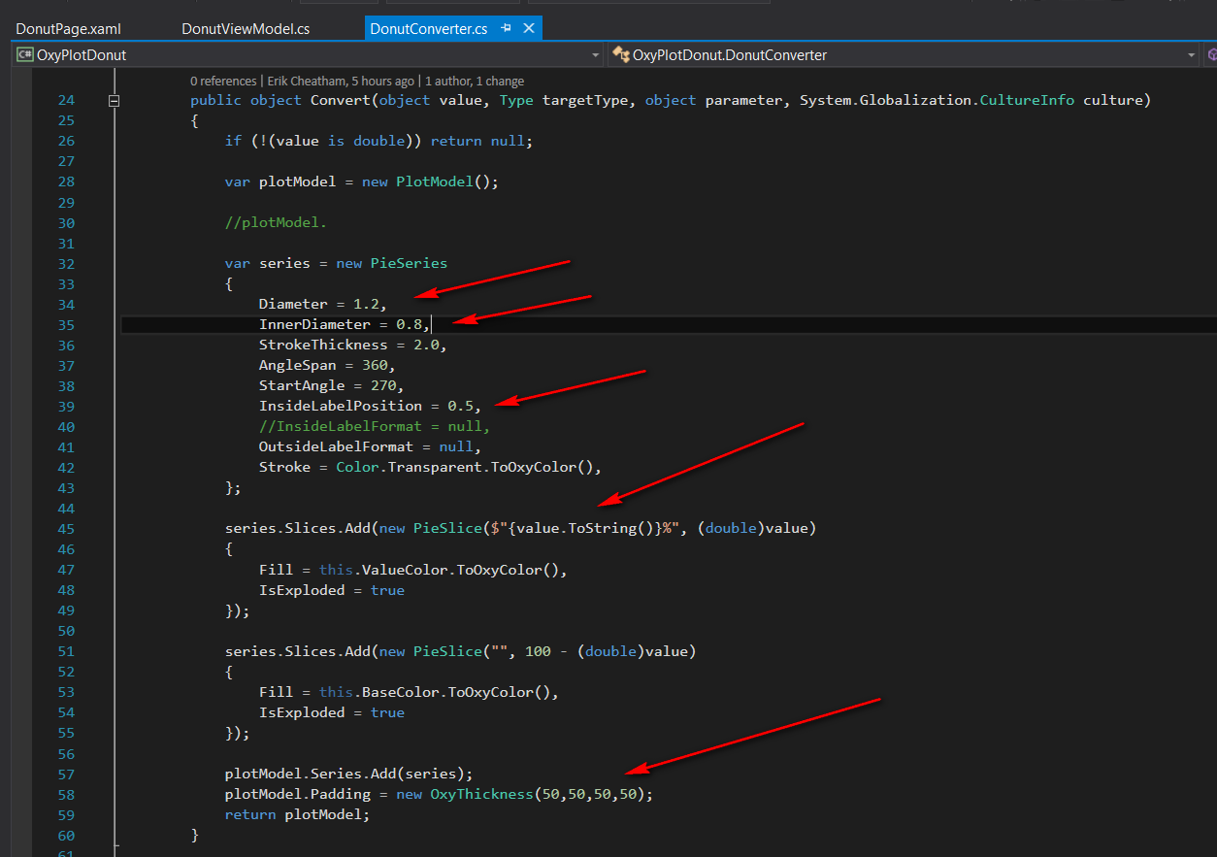

​The Pie Chart part of OxyPlot has several values which can be used for creating a donut chart and tweaked to different sizes.  Diameter and inner diameter contrast to form the thickness of the actual filled in pie line